**BENEFICIARY CARD:**  Solomon Invest SRL - Sf. Lazar

**Activity profile:** renting and leasing of own of rented properties

**Renters activity profile:** Software development

Advocacy

Medical recovery, labor medicine (Arcadia)

**Number of employees in the bulding:** Approximate of 260

**Organizational structure:** Employers of the building

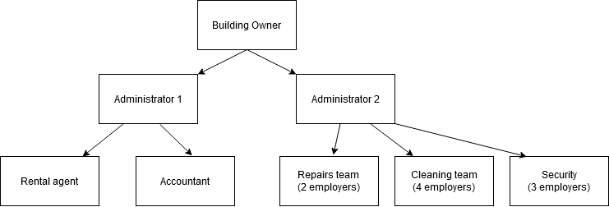

**Organizational structure of an IT Company:**

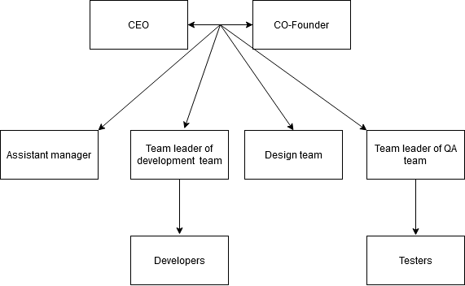

**Development plans:**

In the next 5 years we want to maintain the best network infrastructure for our renters. Also we will develop a platform in which every employee can supervise their desk from phone and also a security system through which every employee has access in the building by access cards.

Something else that we have in plan is to rent the entire building and reach the maximum number of people in the building (300).

**Sketch of the building**: Dimensions 28 X 28 meters

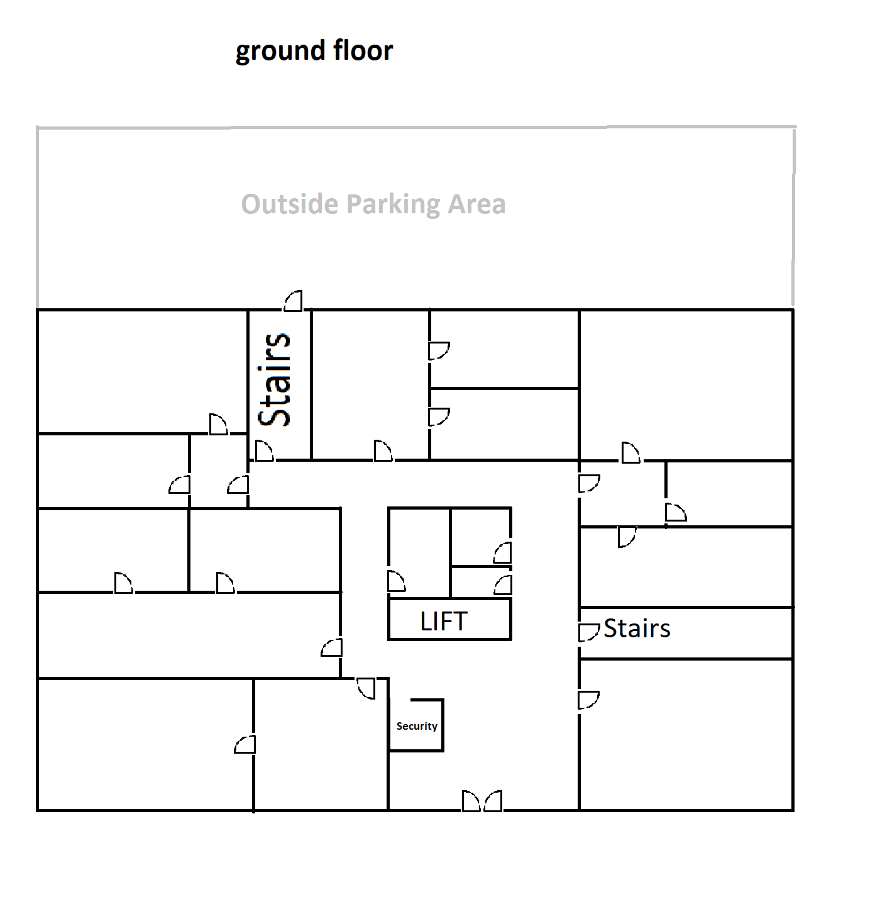

Here is the center of activity of Solomons Invest SRL and also the space is rented by Sprybase(20), Motroplita Life(20), and three law offices(10) with an total of number of 50 employers

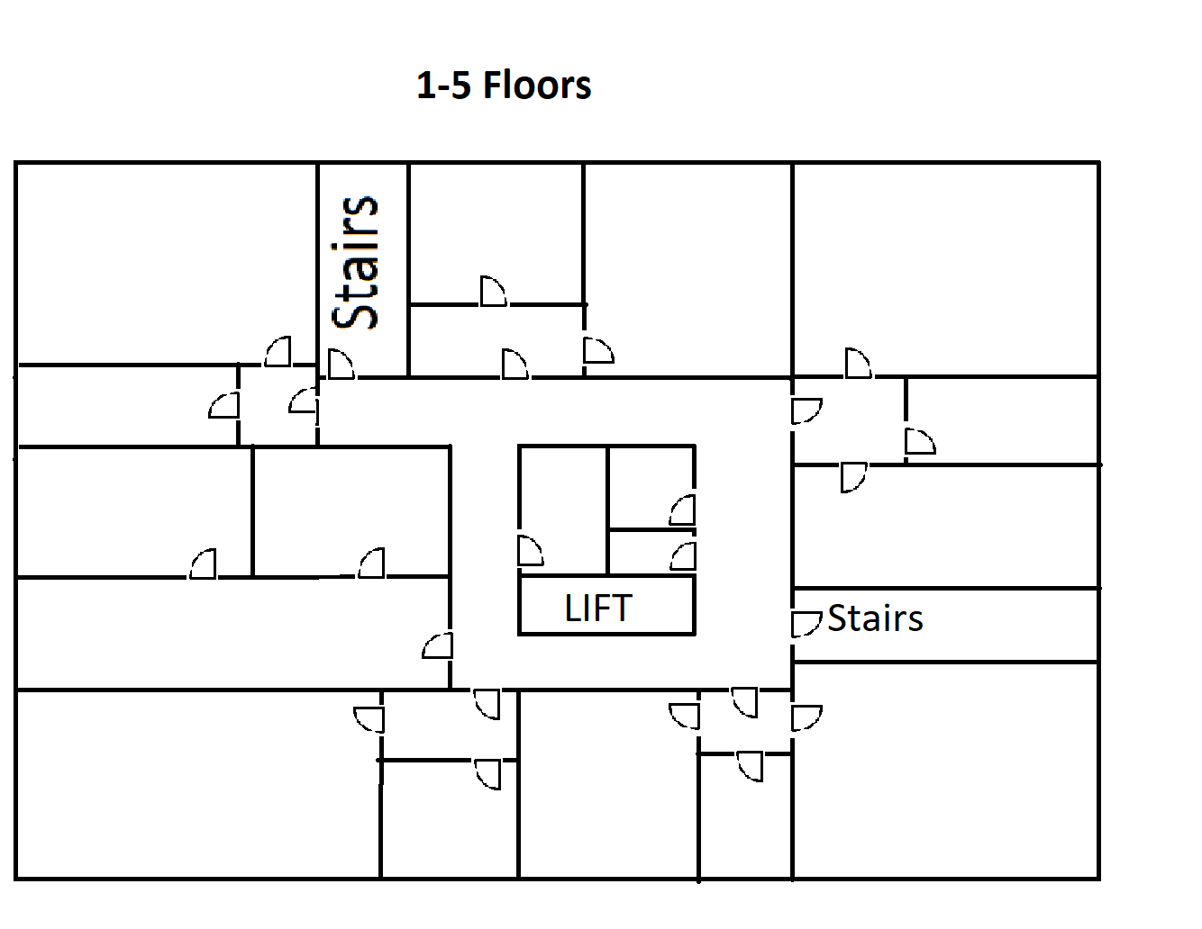

First floor is rented by Neuro Software and has 40 employees.

Second floor is rented by Feel IT and has 52 employees.

Third floor is rented by Maxcode and has 54 employees.

Fourth floor is rented by Smart2Pay and has 40 employees

The fiftsh floor is empty

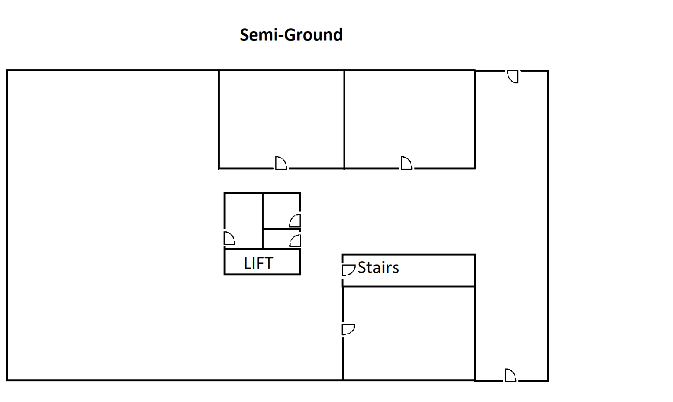

At this floor the renter is Arcadia Hospital. It has 13 employees.

Needs a lot of space for the medical equipament.